**Usage Manual**

To enable Wunderlist integration for a Teamchat group write keyword “help” in your group. The WnderlistBot will list all the commands available for the room. Following are the commands available for this integration:

* connect: connect your evernote
* lists: view your lists
* addlist: add list to wunderlist account
* viewinbox: to view tasks present in your inbox
* addtask: to add task present in all your lists
* disconnect: disconnect your evernote

If you want to access multiple evernote accounts you need to type "disconnect" and then type "connect" to reconnect to different account.

To view all the list present in your Wunderlist account type the keyword “list”, the Bot will post a chatlet containing all the lists:

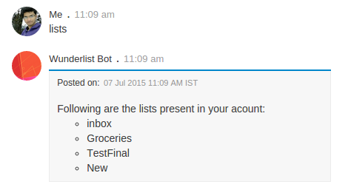

addlist: add a new list to you Wunderlist account

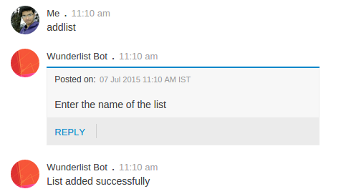

viewinbox: view all the task present in your inbox

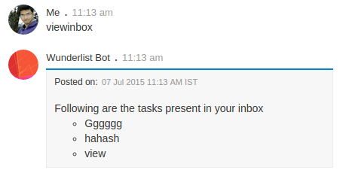

addtask: add task to desired list by selecting the list from a dropdown button.

